Mathematical Modeling:
The Vector Field Algorithm is based on the idea of constructing a vector field that guides the swarm of quadrotor UAVs towards their desired destination while avoiding obstacles. The vector field is constructed by defining a set of attractive and repulsive forces that act on the quadrotor UAVs. The attractive force is defined as a function of the distance between the UAV and its desired destination, while the repulsive force is defined as a function of the distance between the UAV and an obstacle. The vector field is then defined as the sum of these two forces.
In the Virtual Rigid Body model, the motion of the UAV is described by a set of equations that define the position, orientation, and velocity of the UAV. The control inputs to the UAV are defined as a set of forces and torques that act on the UAV. The Vector Field Algorithm uses these equations to define the attractive and repulsive forces that are used to construct the vector field.
Certainly! Here are the mathematical equations that describe the Vector Field Algorithm:
Let P_i be the position of the ith UAV, and D_i be the desired destination for that UAV. Let O_j be the position of the jth obstacle in the environment.
The attractive force F_att acting on the ith UAV towards its desired destination is defined as:

$$F_att = k_att * (D_i - P_i)$$
where k_att is a constant that determines the strength of the attractive force.

The repulsive force F_rep acting on the ith UAV away from the jth obstacle is defined as:

$$F_rep = k_rep * (1 / d_i_j - 1 / r) ^ 2 * n_i_j$$

where k_rep is a constant that determines the strength of the repulsive force, d_i_j is the distance between the ith UAV and the jth obstacle, r is the radius of the obstacle, and n_i_j is the unit vector pointing from the ith UAV to the jth obstacle.
The total force F_total acting on the ith UAV is the sum of the attractive and repulsive forces:

$$F_total = F_att + ∑ F_rep$$

where the sum is taken over all obstacles j in the environment.

The control inputs for the ith UAV are defined as:

$$u_i = K * F_total$$
where K is a constant matrix that converts the force into the appropriate forces and torques needed to control the UAV, such as thrust, roll, pitch, and yaw.
The movement of the ith UAV is described by the VRB model dynamics:

$$M * (d/dt)(v_i) = F_i$$

$$I * (d/dt)(ω_i) = τ_i$$
where v_i is the velocity of the ith UAV, ω_i is its angular velocity, F_i is the total force acting on the UAV, τ_i is the total torque acting on the UAV, M is the mass matrix, and I is the inertia matrix.
Finally, the obstacle detection algorithm checks for any obstacles in the path of the UAV during its movement. If an obstacle is detected, the control inputs are recalculated to avoid the obstacle, and the UAV continues towards its desired destination.
These equations form the mathematical basis for the Vector Field Algorithm and the VRB model. The algorithm can be implemented in MATLAB to simulate the motion of a swarm of quadrotor UAVs in an environment with obstacles, and to optimize the parameters such as k_att and k_rep to achieve the desired performance.

Description of the Vector Field Algorithm:
The Vector Field Algorithm consists of the following steps:
- Initialization: The swarm of quadrotor UAVs is initialized in the environment with obstacles. The desired destination for each UAV is also defined.
- Vector Field Construction: The vector field is constructed using the VRB model dynamics and obstacle avoidance techniques. The attractive force is defined as a function of the distance between the UAV and its desired destination, while the repulsive force is defined as a function of the distance between the UAV and an obstacle. The vector field is then defined as the sum of these two forces.
- Control Inputs Calculation: The control inputs for each UAV are calculated based on the vector field. The control inputs are defined as a set of forces and torques that act on the UAV. The control inputs are designed to move the UAV towards its desired destination while avoiding obstacles in its path.
- UAVs Movement: The UAVs move according to the calculated control inputs. The movement of the UAVs is described by the VRB model dynamics, which includes the position, orientation, and velocity of the UAV. The VRB model dynamics are used to update the position and orientation of each UAV based on the calculated control inputs.
- Obstacle Detection: During the UAVs' movement, the obstacle detection algorithm checks for any obstacles in their path. If an obstacle is detected, the algorithm recalculates the control inputs to avoid the obstacle.
- Termination: The algorithm terminates when all UAVs have reached their desired destination or when a pre-defined time limit has been reached.
The Vector Field Algorithm is widely used in the field of robotics due to its simplicity and effectiveness. It can be used to control the motion of a swarm of robots in a variety of environments, including indoor and outdoor environments. The algorithm can also be modified to incorporate other control techniques to improve its performance, such as formation control or cooperative control.

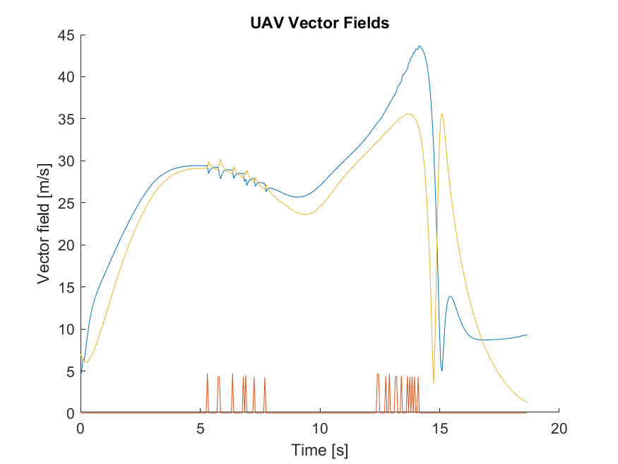
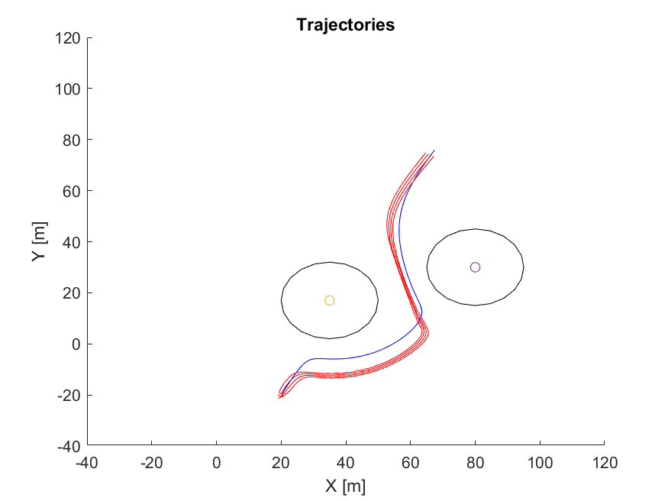
Results
